DOMINO'S PIZZA
Customer Sentiment, Emotion & Brand Perception Analysis Report
A Cross-Platform Social Listening Study
Brand: Domino's Pizza
Period Covered: December 2016 – July 21, 2026 (comment dates); primary volume concentrated Jan–Jul 2026
Data Source: 135 manually collected, publicly visible customer comments across X (Twitter), Facebook, Instagram, TikTok and YouTube
Prepared For: Executive Leadership — CEO, Marketing Director, Customer Experience Manager, Operations Manager, Board
Analyst: Peter Nnamdi Ileh
Report Date: July 22, 2026
Classification: Internal — Academic Case Study (AI Development Training Programme)

Executive Summary
This report analyzes 135 customer comments about Domino's Pizza, manually collected on July 21, 2026 from five public social platforms: Instagram, YouTube, TikTok, Facebook and X (Twitter). It combines sentiment analysis, emotion detection, aspect-based sentiment, topic and entity extraction, complaint/praise categorization and opportunity mapping to answer one question for leadership: what are customers saying, how do they feel, why, and what should the company do about it?
Overall sentiment skews negative: 48.9% of comments were negative, 27.4% positive, 20.7% neutral and 3% mixed. The dominant emotions are Frustration (22.2%), Disappointment (20%) and Anger (18.5%), driven largely by operational failures — late or mishandled delivery, order inaccuracy, unresponsive customer service and perceived price increases — rather than by the core product itself.
Taste is simultaneously the brand's biggest asset and a live risk: it is the single most-discussed aspect (30 mentions) and skews positive overall, but a meaningful minority of comments describe quality inconsistency, ingredient substitution (notably in the India market) and a small number of serious food-safety complaints that warrant urgent attention.
Complaints (62 comments, 46% of the dataset) cluster around five recurring failure points: food quality inconsistency, poor customer service, price/value perception, late delivery, and payment/billing issues. Praise (19 comments) is narrower and almost entirely taste-driven, with comparatively little brand credit for service, delivery or value — a gap leadership should treat as a strategic vulnerability, not a data artifact.
Platform behaviour differs sharply: Facebook and Instagram carry the heaviest negative load (complaint-style, often location-tagged posts), while TikTok and YouTube skew positive and reflect brand affinity, nostalgia and menu-item enthusiasm. This points to a service-recovery gap on the platforms customers use to complain, and an underused advocacy opportunity on the platforms where they already speak positively.
Recommendations are organized into Immediate (0–30 days), Medium-term (1–6 months) and Long-term (6–12 months) priorities in Section 16, anchored on three themes: (1) close the customer-service and complaint-response loop, especially on Meta platforms; (2) protect and standardize food quality and order accuracy across locations and markets; (3) address price/value perception and delivery experience before they erode the loyalty base that currently anchors the brand's positive sentiment.
Methodology note: this is a small, manually assembled sample (n=135) gathered for an academic AI-development exercise, not a statistically representative survey. Directional patterns are credible and internally consistent; point percentages should be read as illustrative signals for executive discussion, not as precise population estimates.

Objectives
This analysis was designed to give decision-makers a single, evidence-based view of the customer experience, structured around the following objectives:
- Quantify overall customer sentiment toward Domino's Pizza across platforms and time.
- Identify the specific emotions driving customer expression, beyond a simple positive/negative label.
- Break sentiment down by business aspect (taste, price, delivery, service, packaging, etc.) so operational owners can see exactly where performance is strong or weak.
- Surface the topics customers raise most often, ranked by frequency, to guide content and communication priorities.
- Extract named entities — locations, staff references, competitors and menu items — to ground findings in specific, actionable detail.
- Categorize complaints and praise into standard operational buckets that map to existing business functions.
- Identify concrete opportunities (new products, market re-entry, service changes) directly requested or implied by customers.
- Translate all of the above into prioritized, time-bound recommendations for the CEO, Marketing Director, Customer Experience Manager and Operations Manager.

Dataset Overview
The dataset consists of 135 manually collected, publicly visible comments referencing Domino's Pizza, gathered on July 21, 2026 between 10:00 and 20:00 WAT. Each record captures the platform, the post/video title under which the comment appeared, the post date, the comment date, and the full comment text.

Composition by Platform
Platform | Comments | Share of Dataset | Dominant Sentiment
Instagram | 31 | 23.0% | Negative
YouTube | 30 | 22.2% | Positive
TikTok | 30 | 22.2% | Positive
Facebook | 23 | 17.0% | Negative
X (Twitter) | 21 | 15.6% | Negative

Date Handling
Several platforms (chiefly YouTube, TikTok and Instagram) display relative timestamps such as “six years ago” or “1w” rather than calendar dates. These were converted to absolute dates using the collection timestamp (July 21, 2026) as the anchor — e.g. “one year ago” = July 21, 2025; “3d ago” = July 18, 2026. Comment dates in the cleaned dataset range from December 20, 2016 to July 20, 2026.
Interpretation caution: YouTube comments on older review videos span 2016–2025 and mostly discuss product/taste topics, while the Facebook, X and recent Instagram/TikTok comments cluster tightly in 2025–2026 and skew heavily toward service complaints. Year-over-year trend comparisons (Section 6) should be read with this composition shift in mind — the apparent recent rise in negative sentiment partly reflects which platforms were sampled more recently, not only a change in underlying customer experience.

Data Cleaning Notes
- 5 rows had no comment ID and were continuation lines of a preceding comment (e.g., a single Facebook complaint split across two rows); these were retained as separate line-level records and attributed to the same platform/post context as the row above them.
- 7 short comments (single mentions such as “@dominos”, or off-topic banter between other commenters) were tagged as off-topic/non-substantive; they are retained in the full dataset for transparency but excluded from sentiment-bearing narrative where noted.
- All 135 records had usable comment text; no comments were discarded from the analysis.

Overall Sentiment Analysis
Across all 135 comments, sentiment splits as follows: 48.9% negative, 27.4% positive, 20.7% neutral, and 3% mixed (comments expressing both praise and criticism in the same message, e.g. loyal customers who are frustrated with a specific recent experience).
Sentiment | Comments | % of Dataset
Positive | 37 | 27.4%
Negative | 66 | 48.9%
Neutral | 28 | 20.7%
Mixed | 4 | 3%

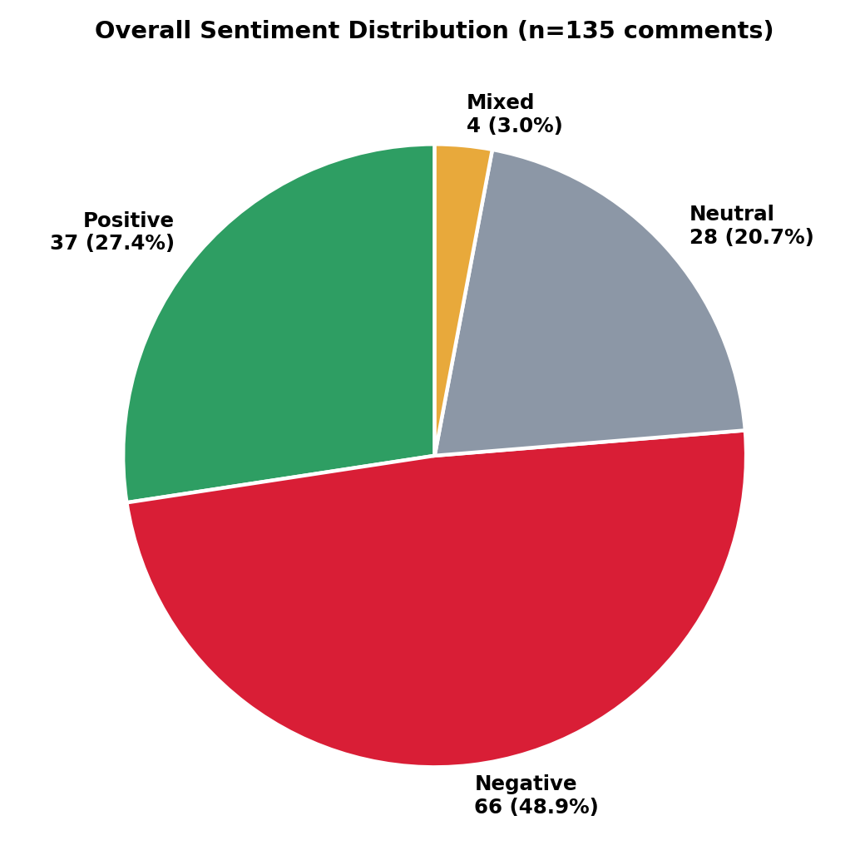
Figure 1. Overall sentiment distribution (n=135).

Reading the Split
- Negative sentiment is concentrated in comments that describe a specific transactional failure (an order, a delivery, a phone call) rather than a general dislike of the brand or product — this is encouraging, because transactional failures are operationally fixable.
- Positive sentiment is concentrated on taste, specific menu items and long-standing brand loyalty, particularly on YouTube and TikTok.
- Neutral comments are largely informational (price comparisons, availability questions, recipe/customization tips) rather than evaluative.
- Mixed comments are an early-warning signal: customers who explicitly pair loyalty language (“I order all the time”) with a fresh complaint are at risk of churning if the underlying issue repeats.

Sentiment Trend Over Time
Comment dates were grouped by year to visualize how sentiment has moved as the sample composition shifted from older YouTube review videos toward more recent, service-focused Facebook, Instagram and X posts.
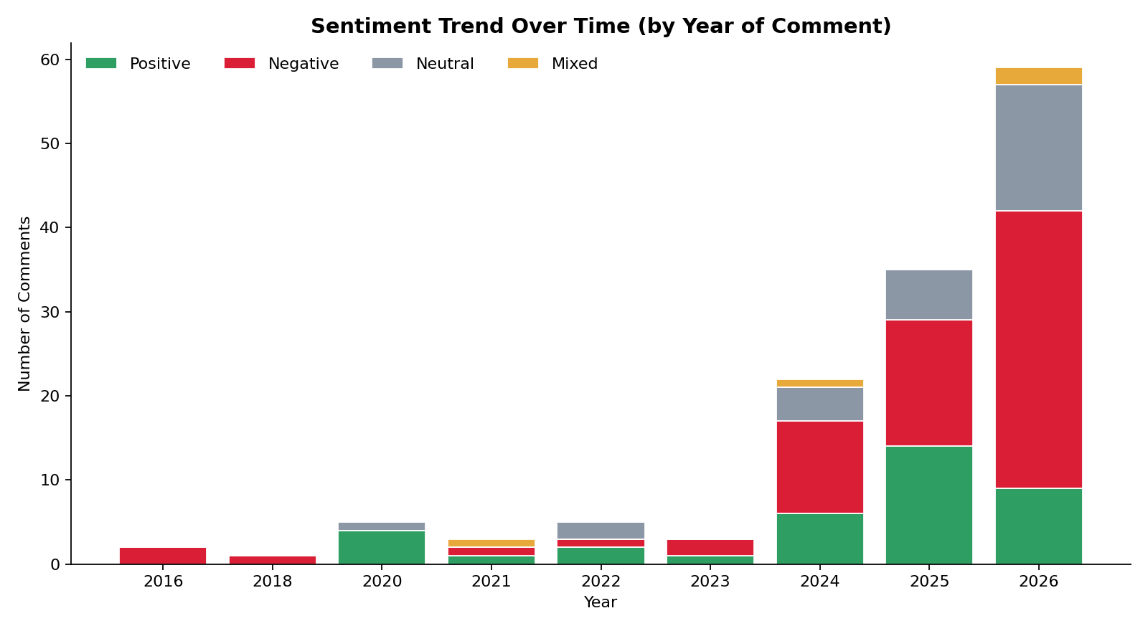
Figure 2. Sentiment composition by year of comment (stacked).
Year | Positive | Negative | Neutral | Mixed | Total
2016 | 0 | 2 | 0 | 0 | 2
2018 | 0 | 1 | 0 | 0 | 1
2020 | 4 | 0 | 1 | 0 | 5
2021 | 1 | 1 | 0 | 1 | 3
2022 | 2 | 1 | 2 | 0 | 5
2023 | 1 | 2 | 0 | 0 | 3
2024 | 6 | 11 | 4 | 1 | 22
2025 | 14 | 15 | 6 | 0 | 35
2026 | 9 | 33 | 15 | 2 | 59

What the Trend Shows
- 2020–2023 (largely YouTube review-video comments): sentiment is majority positive, centered on taste, crust style and nostalgia.
- 2024–2026: volume rises sharply and negative sentiment becomes dominant, coinciding with the addition of Facebook "customer complaints" threads, X service complaints, and recent Instagram posts that are disproportionately complaint-driven.
- 2026 alone accounts for 59 comments (44% of the dataset) and is 56% negative — the most decision-relevant slice for current operational planning, though it should not be read as a literal year-over-year decline given the sampling caveat in Section 4.
Because this sample was assembled manually rather than drawn as a random or stratified panel, the trend line reflects both real shifts in customer experience and which posts happened to be available/selected for collection. Leadership should validate this directional read against internal complaint-ticket volume and CSAT trend data before treating it as a standalone KPI.

Emotion Analysis
Beyond positive/negative labels, each comment was coded for up to two dominant emotions from a 20-emotion taxonomy (Joy, Satisfaction, Trust, Love, Excitement, Surprise, Anger, Frustration, Disappointment, Disgust, Fear, Confusion, Hope, Loyalty, Gratitude, Regret, Jealousy, Impatience, Relief, Anticipation). 18 of the 20 emotions were detected in the sample; Relief and Jealousy did not appear.
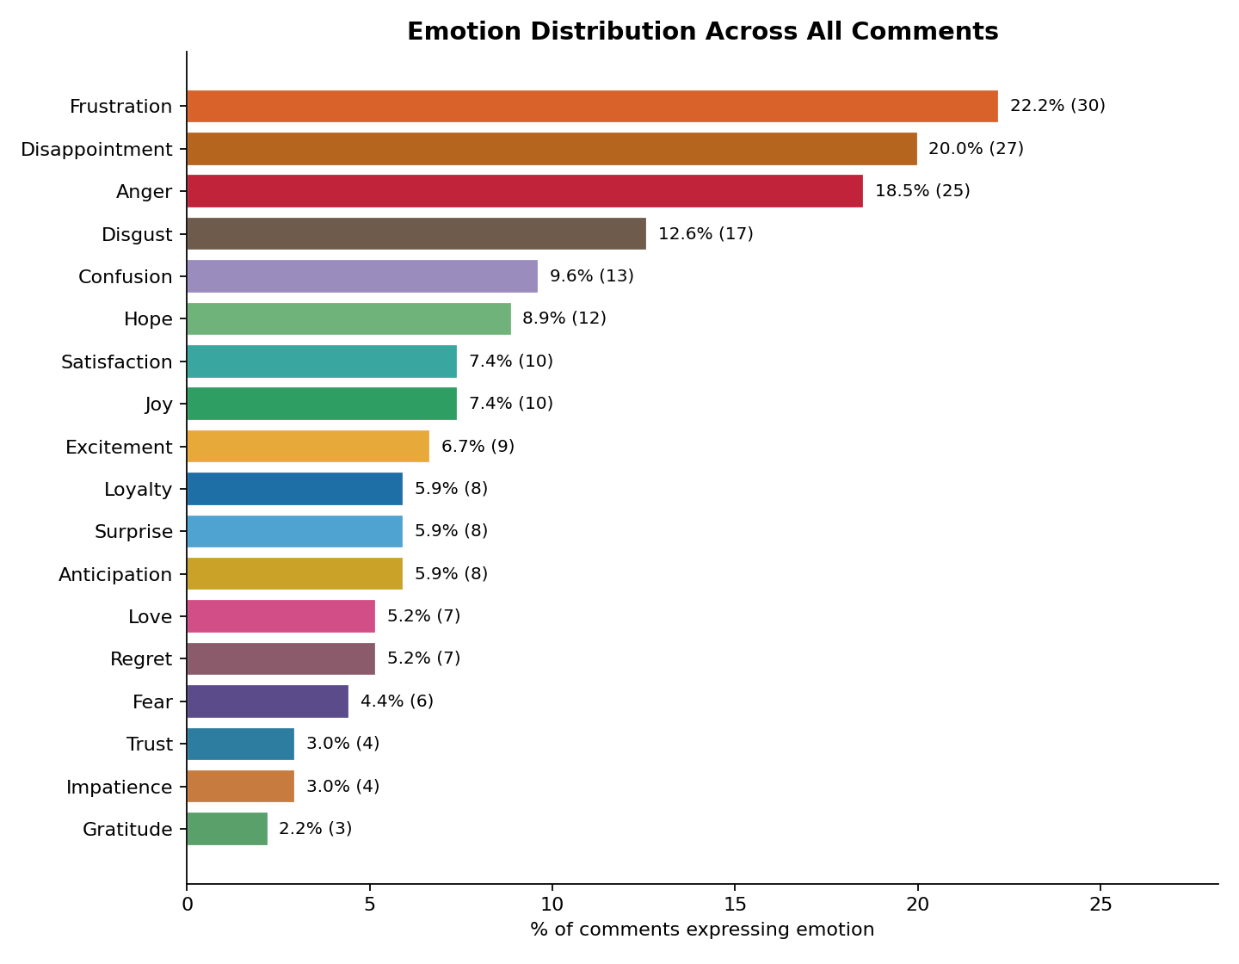
Figure 3. Emotion distribution as % of all comments (a comment may carry up to two emotions).
Emotion | Comments | % of Dataset
Frustration | 30 | 22.2%
Disappointment | 27 | 20%
Anger | 25 | 18.5%
Disgust | 17 | 12.6%
Confusion | 13 | 9.6%
Hope | 12 | 8.9%
Satisfaction | 10 | 7.4%
Joy | 10 | 7.4%
Excitement | 9 | 6.7%
Loyalty | 8 | 5.9%
Surprise | 8 | 5.9%
Anticipation | 8 | 5.9%
Love | 7 | 5.2%
Regret | 7 | 5.2%
Fear | 6 | 4.4%
Trust | 4 | 3%
Impatience | 4 | 3%
Gratitude | 3 | 2.2%

Emotional Drivers, In Context
- Frustration (22.2%) and Disappointment (20%) together dominate the emotional register, and both are almost always tied to a specific failed expectation — a promised delivery time, an advertised portion size, a promotional price, or a promised call-back.
- Anger (18.5%) appears when a customer feels dismissed or disrespected — most acutely in staff-behaviour and discrimination-related complaints — rather than from product quality alone.
- Disgust (12.6%) clusters around food-safety and hygiene complaints (a foreign object, an unpleasant smell/taste, "shampoo chemicals" rumor) and deserves a disproportionate share of leadership attention relative to its raw frequency, given brand and safety risk.
- Positive emotions — Joy, Satisfaction, Love, Excitement, Loyalty, Trust, Gratitude — collectively appear in roughly a third of comments and are concentrated on taste, specific menu items, and long-tenure customers (e.g., multi-year rewards members).
- Hope and Anticipation (8.9% and 5.9% respectively) are notable because they are largely attached to product requests — vegan cheese, discontinued items, market re-entry — representing a receptive audience for a responsive product roadmap.

Brand Perception Analysis

How Do Customers Describe Domino's Pizza?
Reading across the full comment set, three distinct “voices” describing the brand emerge, often from the same customer within a single comment:

1. “Loyal but let down” — the largest and most strategically important voice
Long-tenure customers (“rewards member for over 8 years”, “our go-to for years”) who describe a specific recent failure and explicitly weigh whether to keep ordering. This voice supplies both the brand's positive anchor and its highest-risk churn signal.
"I love dominoes... Order all the time. But I will say that you don't know what ‘light’ or ‘extra’ mean." — Facebook
"I like dominoes but sometimes you wonder if the drivers have rocks for brains." — Facebook

2. “Great pizza, inconsistent execution”
A large share of both praise and complaint centers on the same underlying theme: when Domino's is executed well, customers rate the taste highly (hand-tossed crust, jalapeño items, BBQ and Alfredo variants); when execution slips — dry crust, thin toppings, cold delivery, wrong size — customers frame it as a betrayal of a product they know can be good.
"Whoever made that pizza need to teach the rest of the Domino workers how to make theirs." — TikTok

3. “Value math doesn't add up”
A recurring, more analytical voice compares advertised prices/deals to what actually arrives — portion size, delivery fees, deal-stacking restrictions — and concludes the brand is engineering the appearance of value rather than delivering it.
"Your delivery fee is like $8 which basically negates the cost of the free pizza... I know your corporate tricks!" — X (Twitter)

4. “Underserved and asking to be included”
A distinct, mostly polite and constructive voice — vegan/dairy-free customers, and customers in markets like South Africa where the brand has withdrawn — asking to be brought back into the addressable market rather than complaining about a bad experience.
"Customers are hungry for change! ...Domino's offers vegan cheese in other countries. So why not here in the U.S.?" — X (Twitter)

Net Read for Leadership
Domino's is not perceived as a low-quality brand; it is perceived as an inconsistent one, where the product customers already love is undermined by execution gaps in delivery, order accuracy, staff conduct and price transparency. This is a materially easier problem to solve than a product-quality reputation deficit, because the fix is operational discipline and communication, not reinvention.

Aspect-Based Sentiment Analysis
Rather than a single brand-level score, each comment was tagged with the specific business aspect(s) it discusses, and sentiment was scored per aspect. This isolates exactly which parts of the experience are working and which are not.
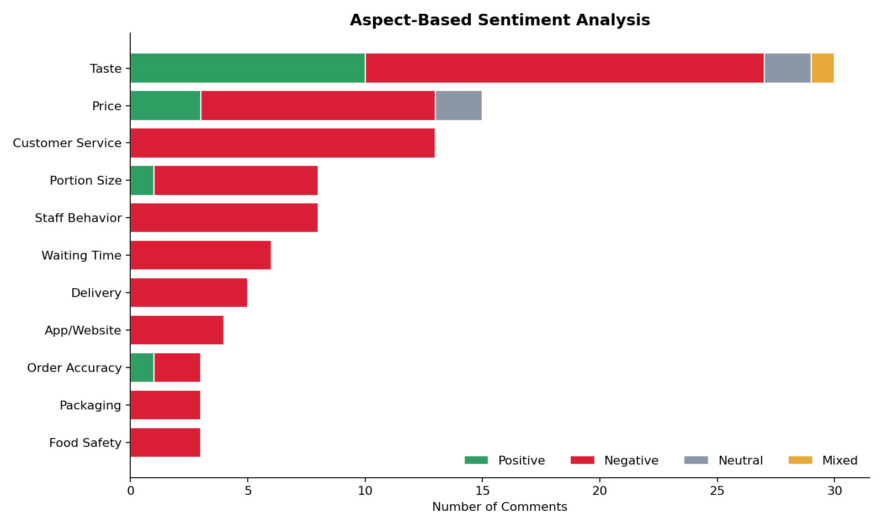
Figure 4. Aspect-based sentiment (aspects with 3+ mentions).
Aspect | Mentions | Positive | Negative | Neutral/Mixed
Taste | 30 | 10 | 17 | 3
Price | 15 | 3 | 10 | 2
Customer Service | 13 | 0 | 13 | 0
Portion Size | 8 | 1 | 7 | 0
Staff Behavior | 8 | 0 | 8 | 0
Waiting Time | 6 | 0 | 6 | 0
Delivery | 5 | 0 | 5 | 0
App/Website | 4 | 0 | 4 | 0
Order Accuracy | 3 | 1 | 2 | 0
Packaging | 3 | 0 | 3 | 0
Food Safety | 3 | 0 | 3 | 0

Aspect-Level Findings
- Taste (30 mentions, majority positive): the strongest asset in the dataset, but with a sizable negative tail tied to inconsistency between locations and, in India, ingredient substitution.
- Price (15 mentions, majority negative): customers are not simply saying “too expensive” — the more common complaint is that pricing/deal structures are confusing, that advertised deals don't match what's charged, or that portions shrink faster than prices are communicated.
- Customer Service (13 mentions, 100% negative): every coded customer-service mention in this sample is negative — the most operationally urgent finding in the aspect analysis.
- Portion Size (8 mentions, mostly negative): frequently paired with price complaints (“shrinkflation” perception) and with “false advertising” language.
- Staff Behavior (8 mentions, 100% negative): a small but reputationally severe cluster, including threats, alleged discrimination, and rudeness — disproportionate risk relative to volume.
- Waiting Time, Delivery, App/Website, Order Accuracy, Packaging (all majority or 100% negative): consistent operational themes rather than isolated incidents.

Topic Analysis
In addition to the operational aspects above, comments were coded for the broader discussion topic they raise, ranked here by frequency. Several topics recur across multiple platforms, which strengthens their signal despite low individual counts in a 135-comment sample.
Rank | Topic | Mentions
1 | Discounts/vouchers | 2
2 | Pricing structure/transparency | 2
3 | Pineapple-on-pizza debate | 2
4 | Brand loyalty humor | 1
5 | Value for money | 1
6 | Crust quality | 1
7 | Availability by region | 1
8 | Consumption occasion | 1
9 | US vs UK pricing | 1
10 | Menu variety | 1
11 | Quality decline (India) | 1
12 | Menu innovation ideas | 1
13 | Overall brand/quality perception | 1
14 | Discontinued Brooklyn style | 1
15 | Discontinued menu item (brownies) | 1
16 | Menu diversification (Nigeria) | 1
17 | Seeking alternatives | 1
18 | Perceived quality in Nigeria market | 1
19 | Reviewer credibility banter | 1
20 | General pizza preference | 1
21 | Pan pizza comparison | 1
22 | Customization tips | 1
23 | Craving/anticipation | 1
24 | Store closure inquiry | 1

Cross-Cutting Themes
- Pricing structure and transparency (deals, tax/tip handling, deal-stacking rules) recurs across US, UK and general comparison discussions — this is a communications problem as much as a pricing one.
- Discontinued menu items (Brooklyn-style crust, Italian Sausage Marinara Pasta, Buffalo Chicken Pizza, brownies, Bread Bowl Pasta) generate a steady stream of unprompted “bring it back” requests, indicating durable nostalgia demand the product team can quantify further.
- The pineapple-on-pizza debate and similar customization banter, while not evaluative of the brand itself, represents low-cost social engagement opportunity (polls, UGC campaigns) already happening organically in the comments.
- Perceived quality decline in specific international markets (India, Nigeria) appears repeatedly and independently across different comments and platforms, suggesting a real regional quality-consistency issue rather than a one-off.

Entity Analysis (Named Entity Recognition)
Named entities mentioned in comments were extracted and grouped into four categories: locations, people, competitor brands, and specific menu items. Entities ground the aggregate findings in concrete, verifiable detail that operational teams can act on directly.

Locations (Store/City/Country-Level Mentions)
20 distinct location references appeared, spanning the US (10), India (4 direct store/city references), Nigeria (3), Canada (1) and South Africa (1). Specific store-level mentions — e.g. Doral FL, Detroit MI (Griswold), Pittsfield MA, Plainview TX, Carrollton/New Orleans LA, Cranston RI, Columbia MD, Maurice LA, Thiruvanmiyur/Chennai, Noida, Krishangarh, Cambridge ON — are individually actionable: each is traceable to one franchise/corporate location for follow-up.
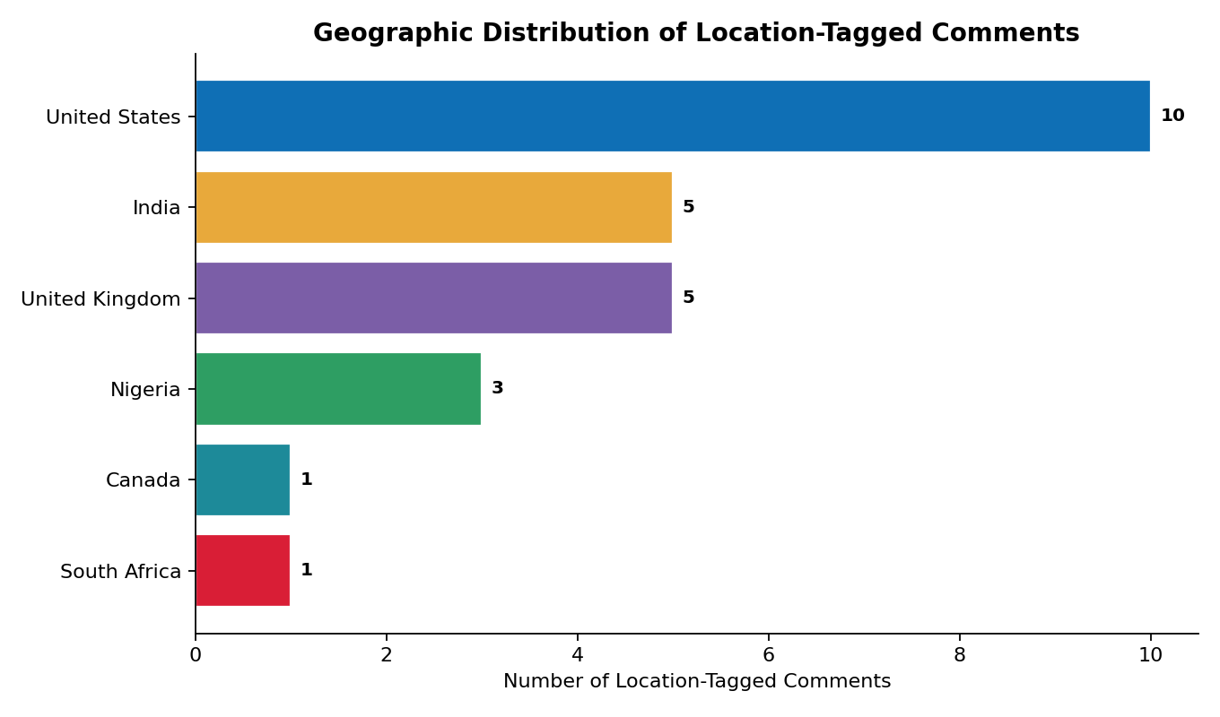
Figure 5. Geographic distribution of comments carrying an identifiable location (country-level roll-up of location and currency mentions).

People
Two named individuals appear: one customer (Rebecca Manning, cited by name in a harassment complaint with a specific corporate Case ID) and one indirect reference to a family member who formerly worked at Domino's. Direct identification of named private individuals should be handled carefully and is noted here only because the customer volunteered her name publicly as part of a corporate complaint.

Competitor Brands
Two competitors were named directly in comparison: Papa John's (pan-pizza comparison, neutral/curious tone) and Marco's Pizza (named as the alternative a customer intends to switch to after a price/value complaint) — a concrete, named competitive-loss signal.

Menu Items Named by Customers
Specific items customers called out by name (positively or negatively) include: hand-tossed crust, Jalapeño bread, Jalapeños, Parmesan bites, Alfredo pizza, Texas BBQ pizza, Oregano seasoning (India), Chicken Bacon Ranch sandwich, Tandoori Loaded Tacos, Veeba sauces, and the 5-cheese topping. This list is a ready-made shortlist for a taste-tracking or menu-engineering review.

Complaint Analysis
62 of 135 comments (46%) contain an identifiable complaint. Complaints were coded into operational categories; several comments trigger more than one category (e.g. a late, cold, wrong-address delivery is coded as both Late Delivery and Wrong Order).
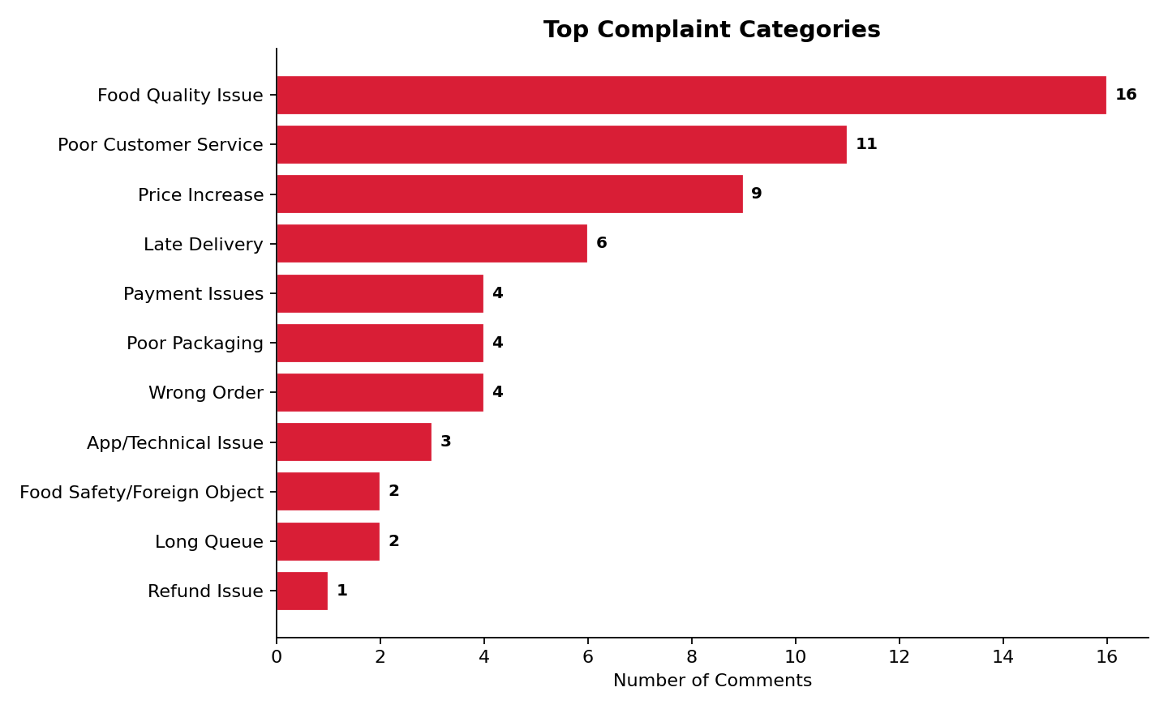
Figure 6. Top complaint categories by comment count.
Complaint Category | Comments | % of All Comments
Food Quality Issue | 16 | 11.9%
Poor Customer Service | 11 | 8.1%
Price Increase | 9 | 6.7%
Late Delivery | 6 | 4.4%
Payment Issues | 4 | 3%
Poor Packaging | 4 | 3%
Wrong Order | 4 | 3%
App/Technical Issue | 3 | 2.2%
Food Safety/Foreign Object | 2 | 1.5%
Long Queue | 2 | 1.5%
Refund Issue | 1 | 0.7%

Category Detail
- Food Quality Issue (16): dry/thin crust, under-topped pizzas, over-salted or over-cooked items, ingredient substitution, and a small number of alarming outlier claims (a foreign object, an unverified “shampoo chemicals” allegation) that warrant a direct food-safety response regardless of how isolated they are.
- Poor Customer Service (11): unresponsive phone lines, rude or dismissive staff, no follow-up after a complaint was filed, and one detailed harassment allegation naming a case ID — this is the single most consistent driver of “never again” language in the dataset.
- Price Increase / Value Perception (9): deal-stacking restrictions removed, shrinking portion sizes at the same price, and delivery-fee stacking that customers describe as eroding advertised value.
- Late Delivery (6) and Long Queue (2): waiting times exceeding quoted estimates, extended “quality check” stages with no communication, and in-store/drive-thru wait times without staff engagement.
- Payment Issues (4), Poor Packaging (4), Wrong Order (4), App/Technical Issue (3), Food Safety/Foreign Object (2), Refund Issue (1): a long tail of specific, individually low-frequency but collectively significant operational failure points.

Praise Analysis
19 comments (14%) contain explicit praise. Compared to the breadth of the complaint taxonomy, praise is narrow and concentrated almost entirely on one theme.
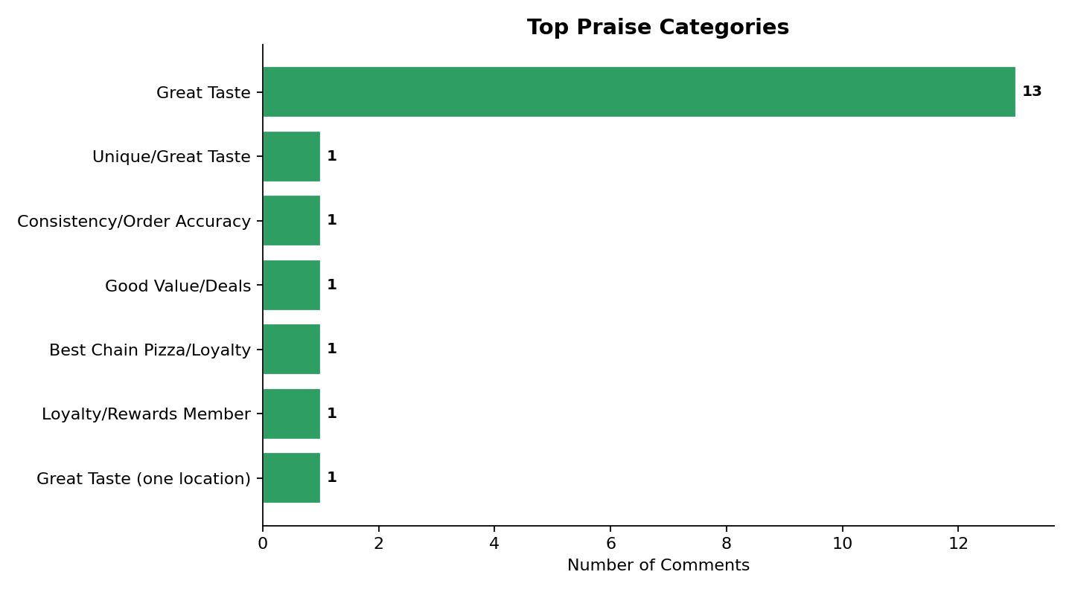
Figure 7. Top praise categories by comment count.
Praise Category | Comments
Great Taste | 13
Unique/Great Taste | 1
Consistency/Order Accuracy | 1
Good Value/Deals | 1
Best Chain Pizza/Loyalty | 1
Loyalty/Rewards Member | 1
Great Taste (one location) | 1

What Delights Customers
- Great taste and specific menu items (crust styles, Alfredo and BBQ variants, jalapeño items, Parmesan bites) is, by a wide margin, the dominant source of positive sentiment.
- Long-tenure loyalty and rewards-program membership (“rewards member for over 8 years”) surfaces as its own praise signal — customers volunteer tenure unprompted as a marker of trust.
- Consistency and order accuracy (“orders have always been spot on and fresh”) is praised, but by far fewer customers than complain about its absence — confirming aspect analysis in Section 9.
- Good value/deals draw enthusiastic praise when the deal is perceived as genuine, in direct contrast to the price complaints in Section 12 — the difference appears to be transparency and follow-through, not the discount mechanism itself.
The narrowness of the praise taxonomy relative to the complaint taxonomy is itself a finding: the brand currently earns almost no credit in this sample for service, delivery, packaging or price fairness — only for the food. A brand-health program that only reinforces taste messaging will not address the service perception gap.

Opportunity Analysis
Beyond fixing complaints, customers directly proposed or implied a set of growth opportunities. These are grouped into three themes.
Opportunity | Signals
Vegan cheese option | 3
Regional topping innovation (paneer) | 1
More innovative pizza launches; more cheese | 1
Bring back pasta | 1
Bring back Italian Sausage Marinara Pasta | 1
Bring back Buffalo Chicken Pizza | 1
Vegan/dairy-free cheese - new market | 1
Bring back Brooklyn style | 1
Market re-entry (South Africa) | 1
Visible glove use for hygiene confidence | 1
Vegan cheese option (US market) | 1
Bring back Bread Bowl Pasta | 1

1. Vegan / Dairy-Free Menu Expansion (Highest-Signal Opportunity)
The single most repeated, most enthusiastic and most substantively argued customer request in the dataset. Customers cite health, lactose intolerance, environmental and ethical reasons, note that Domino's already offers vegan cheese in other countries, and reference the growing vegan food market — making this a well-evidenced, low-ambiguity product opportunity for the US market specifically.

2. Menu Nostalgia / Win-Back Items
Discontinued items (Brooklyn-style crust, Italian Sausage Marinara Pasta, Buffalo Chicken Pizza, brownies, Bread Bowl Pasta) each generated unprompted “bring it back” requests. A limited-time revival campaign is a low-risk way to re-engage lapsed, nostalgia-driven customers who are otherwise not currently complaining — they've simply quietly stopped ordering the discontinued item.

3. Regional Menu Innovation and Market Re-Entry
Customers proposed region-specific innovation directly (e.g. paneer as a topping in UK/India contexts) and asked for market re-entry in South Africa. Both suggest customer-led signals for regional menu and market-expansion planning that marketing and international operations can validate against internal data.

Visualizations
The charts referenced throughout this report are consolidated here for quick executive reference, alongside a word cloud summarizing the most frequent terms across all 135 comments (brand and generic stopwords removed).
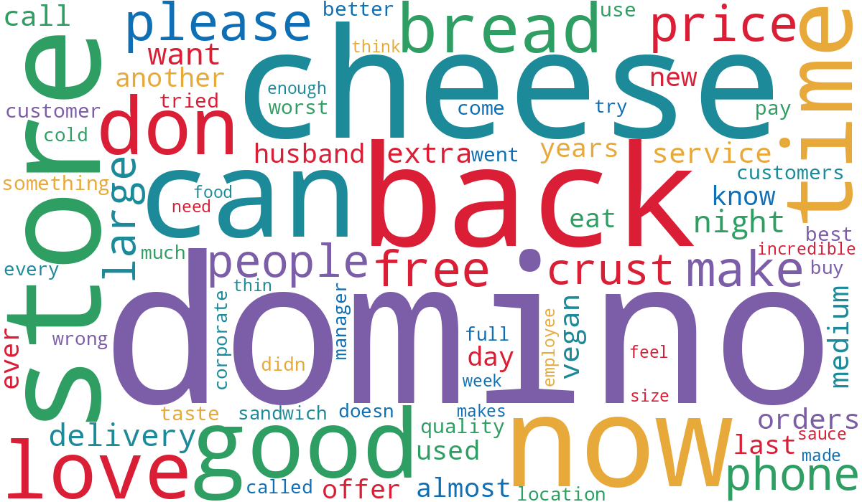
Figure 8. Word cloud of most frequent terms across all comments.

Chart Index
- Figure 1 (Section 5): Overall sentiment distribution — pie chart.
- Figure 2 (Section 6): Sentiment trend over time — stacked bar by year.
- Figure 3 (Section 7): Emotion distribution — horizontal bar, % of comments.
- Figure 4 (Section 9): Aspect-based sentiment — stacked horizontal bar.
- Figure 5 (Section 11): Geographic distribution of location-tagged comments — horizontal bar.
- Figure 6 (Section 12): Top complaint categories — horizontal bar.
- Figure 7 (Section 13): Top praise categories — horizontal bar.
- Figure 8 (this section): Word cloud.
A true geographic heat map requires a larger set of precisely geocoded comments than this sample provides (20 location-bearing comments across 6 countries). The ranked bar chart in Figure 5 presents the same information honestly, without implying a precision the underlying data doesn't support.

Actionable Recommendations
Recommendations are grouped by time horizon and assigned a suggested executive owner. They are derived directly from the complaint, praise, aspect and opportunity findings above.

Immediate (0–30 Days)
Recommendation | Owner | Why It Matters
Stand up a same-day response protocol for Facebook/Instagram/X complaint comments, especially those naming a specific store, city or employee. | CX Manager | 13 customer-service mentions were 100% negative; unresolved public complaints compound reputational damage.
Issue an internal food-safety alert and audit trail for the foreign-object and product-contamination complaints identified in this sample, regardless of volume. | Operations Manager | Even isolated safety complaints carry outsized brand and legal risk.
Audit and clearly republish current deal terms (stacking rules, delivery-fee disclosure, tax/tip handling by market) in-app and on receipts. | Marketing Director | Price complaints are driven more by perceived opacity than by price level itself.
Send a direct follow-up to the small number of customers who named specific unresolved cases (e.g. refund, harassment, ADA/service-animal complaint) in this sample. | CX Manager | These are the highest-severity, most reputationally exposed complaints in the dataset.

Medium-Term (1–6 Months)
Recommendation | Owner | Why It Matters
Introduce a standardized order-accuracy and portion-consistency checklist at store level, with mystery-shopper spot checks in flagged markets (India, Nigeria, and the specific US cities named in this report). | Operations Manager | Taste and portion inconsistency is the most-cited driver of both complaints and lost loyalty.
Pilot a vegan/dairy-free cheese option in one or two US test markets, benchmarked against markets where it already exists. | Marketing Director / Product | Highest-signal, well-argued, low-ambiguity customer request identified in this study.
Run a limited-time “fan favorites” revival campaign featuring the most-requested discontinued items (Brooklyn-style crust, Buffalo Chicken Pizza, Bread Bowl Pasta). | Marketing Director | Converts nostalgia demand already visible in comments into a low-risk, time-boxed marketing moment.
Formalize a service-recovery workflow for delivery failures (late, cold, wrong-address) with proactive refund/credit authority at the call-center level. | CX Manager / Operations | Several “never ordering again” comments could plausibly have been retained with a faster, empowered response.

Long-Term (6–12 Months)
Recommendation | Owner | Why It Matters
Build a lightweight ongoing social-listening dashboard (sentiment, emotion, complaint category) so this snapshot becomes a trend line rather than a one-time study. | Marketing Director / Analytics | Converts this academic exercise into a repeatable operational tool.
Commission a market-specific quality-consistency review for India and Nigeria operations, given repeated, independent quality-decline comments from both markets. | Operations Manager / International | Multiple unrelated comments describing the same regional pattern suggest a systemic rather than anecdotal issue.
Evaluate a phased vegan/dairy-free menu rollout beyond the pilot, tied to observed demand and unit economics. | Product / Finance | Scales the medium-term pilot if it validates.
Assess the business case for re-entering previously exited markets (e.g., South Africa) referenced by name in customer comments. | Strategy / International Development | Direct customer-voiced demand for market re-entry is a low-cost input into a larger market-sizing exercise.

Conclusion

Overall Customer Perception
Domino's Pizza is perceived, in this sample, as a brand with genuine and durable product affinity that is repeatedly undercut by inconsistent execution — primarily in delivery, customer service, order accuracy and price transparency, rather than in the core recipe or menu concept.

Key Emotional Drivers
Frustration, Disappointment and Anger dominate negative expression and are almost always anchored to a specific, nameable operational failure. Joy, Satisfaction, Love and Loyalty dominate positive expression and are anchored to taste and long customer tenure. Hope and Anticipation mark an engaged audience that is actively asking the brand to bring back or add specific products.

Major Operational Strengths
- Core product taste, when executed to standard, generates strong, specific, unprompted praise.
- A visible base of long-tenure, multi-year loyal customers who default to defending the brand even while raising a complaint.
- Deals and promotions that are perceived as genuine (not just “price increase”) generate enthusiastic praise.

Critical Weaknesses
- Customer service is the single most consistently negative aspect in the dataset — 100% of coded mentions were negative.
- Price/value perception is undermined more by structural opacity (deal-stacking rules, fee disclosure, shrinking portions) than by headline price.
- A small but reputationally severe cluster of staff-behaviour, discrimination and food-safety complaints requires case-by-case executive attention regardless of statistical weight.

Strategic Priorities
1) Close the service-recovery loop on complaint-heavy platforms; 2) standardize food quality and order accuracy across locations and international markets; 3) rebuild pricing trust through transparency rather than discount depth; 4) convert nostalgia and vegan/dairy-free demand into a low-risk product roadmap.

Expected Business Impact if Recommendations Are Implemented
Addressing the customer-service and order-accuracy gaps directly targets the complaints most associated with “never ordering again” language, protecting the loyal-customer base that already anchors positive sentiment. Improving price transparency should reduce the “corporate tricks” framing that currently erodes trust even among customers who like the product. The vegan/dairy-free and nostalgia-menu opportunities offer incremental revenue with comparatively low execution risk, since demand signals are already organic and unprompted in the customer base. Collectively, these actions are aimed at converting today's “loyal but let down” customer voice into simply a “loyal” one, closing the gap between what customers already love about the product and what they experience around it.

— End of Report —

